Experiment No-03
Simulation of Multiplexers using Verilog
1.1 Objectives
The main objectives of this experiment are summarized as:
- To become familiar with the Cadence Incisive Enterprise Simulator (IES) and the NCLaunch design flow.
- To write structural/dataflow and vector-based Verilog models of 2-to-1, 4-to-1, and 8-to-1 multiplexers.
- To write self-checking test bench (stimulus) modules and verify each design using the SimVision waveform viewer.
- To practice compiling, elaborating, and simulating a Verilog design using ncvlog, ncelab, and the simulator within NCLaunch.
Keywords- Multiplexer (MUX), Verilog HDL, dataflow modeling, vector-based modeling, Cadence Incisive Enterprise Simulator (IES), NCLaunch, SimVision, test bench, waveform verification.
1.2 Theory
1.2.1 Multiplexers (MUX)
A multiplexer (MUX) is a combinational logic circuit that selects one of several input signals and forwards it to a single output line, based on the value of one or more selector (select) lines. An n-to-1 multiplexer has n data inputs, ⌈log₂ n⌉ select lines, and a single output; the select lines act as a binary address that determines which one of the n inputs is connected to the output at any given time. Multiplexers are fundamental building blocks in digital systems, where they are used for data routing, bus switching, and as general-purpose logic elements capable of implementing arbitrary Boolean functions. The truth table of the simplest case, a 2-to-1 MUX with data inputs i0 and i1 and select line s, is shown in Table-1.1. In this experiment, three multiplexers of increasing size a 2-to-1, a 4-to-1, and an 8-to-1 MUX were described in Verilog HDL and verified through simulation.
s (Select) | out (Output)
0 | i0
1 | i1
Table-1.1. Truth table of a 2-to-1 multiplexer with data inputs i0, i1 and select line s.
1.2.2 Verilog Modeling Styles Used
Combinational logic in Verilog can be described at several levels of abstraction. A dataflow description uses continuous assignment (assign) statements built from Boolean and conditional (?:) operators to describe how the output depends on the inputs, without specifying the underlying gate structure; a structural description instead builds the circuit explicitly from instances of lower-level modules or primitive gates; and a behavioral description uses procedural constructs (such as always blocks with case or if statements) operating on register (reg) variables. In this experiment, all three multiplexers were described using continuous assignment (dataflow) statements built around the conditional operator: the 2-to-1 MUX used a single-bit conditional expression on scalar inputs, while the 4-to-1 and 8-to-1 MUXes extended this to vector-based descriptions, in which the data inputs and select lines were declared as multi-bit input vectors ([3:0], [1:0], etc.) and a nested conditional expression selected the addressed bit directly from the input vector. This vector-based, nested-conditional style scales more compactly than instantiating multiple 2-to-1 MUX primitives, while still remaining a dataflow (rather than explicitly structural or procedural/behavioral) description.
1.2.3 Cadence Incisive Enterprise Simulator (IES) and the NCLaunch Design Flow
The Cadence Incisive Enterprise Simulator (IES), invoked through the NCLaunch graphical front end, was used to compile, elaborate, and simulate each Verilog design. The design flow consists of four steps: (1) creating a cds.lib library-mapping file and a worklib work library for the design; (2) compiling the design and test bench source files with ncvlog, which checks Verilog syntax and semantics and reports any errors in the NCLaunch Command Entry Window; (3) elaborating the compiled design with ncelab, using the test bench as the top-level module (since it instantiates the design under test) to build the design hierarchy and connect the signals between the test bench and the design; and (4) launching the simulator on the resulting worklib snapshot, which opens the Design Browser, Console, and Waveform windows of SimVision, where the test bench’s $monitor output can be read in the Console and the input, selector and output signals can be inspected as timing diagrams in the Waveform window.
1.3 Hardware/Software Used for the Experiment
1. Cadence Incisive Enterprise Simulator (IES), invoked through NCLaunch
2. ncvlog (Verilog compiler), ncelab (elaborator), and the Incisive simulator (ncsim)
3. SimVision waveform viewer (Design Browser, Console, and Waveform windows)
4. gedit text editor, used to write the Verilog source and test bench files
5. Verilog HDL, with a simulation timescale of 1 ns / 1 ps
6. Linux workstation running the Cadence design environment
1.4 Experimental and Simulation Analysis
For each of the three multiplexers, a lab directory and simulation sub-directory were created, the Verilog source and test bench files were written in gedit, and a cds.lib file mapping a worklib work library was created in NCLaunch (selecting the “Don’t include any libraries (Verilog design)” option, since no VHDL libraries were required). Each design was then compiled with ncvlog, elaborated with ncelab using the test bench as the top-level module, and simulated with the Incisive simulator, and the resulting wave-forms were inspected in SimVision. The steps and results for each of the three multiplexers are presented in the following subsections.
1.4.1 2-to-1 Multiplexer (mux21)
The 2-to-1 multiplexer was described using a single dataflow (continuous assignment) statement with a conditional operator, selecting between the two scalar data inputs i0 and i1 based on the scalar select line s. The Verilog source code is shown in Figure-1.1.
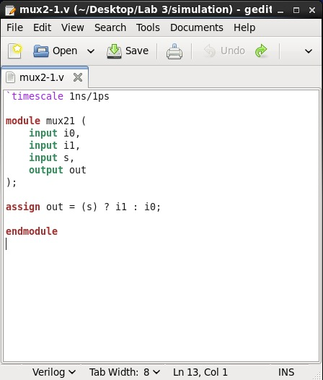
Figure-1.1. Verilog source code (mux21.v) for the 2-to-1 multiplexer: a single continuous-assignment statement, out = s ? i1 : i0, describing a dataflow 2-to-1 MUX with scalar inputs i0, i1 and select line s.
A self-checking test bench (mux21_test.v) was written to apply six stimulus combinations to the design under test (uut), each held for 10 ns, covering both values of i0 and i1 together with both values of the select line s, and a $monitor statement was used to print the value of every signal to the console whenever any of them changed. The test bench source code is shown in Figure-1.2.
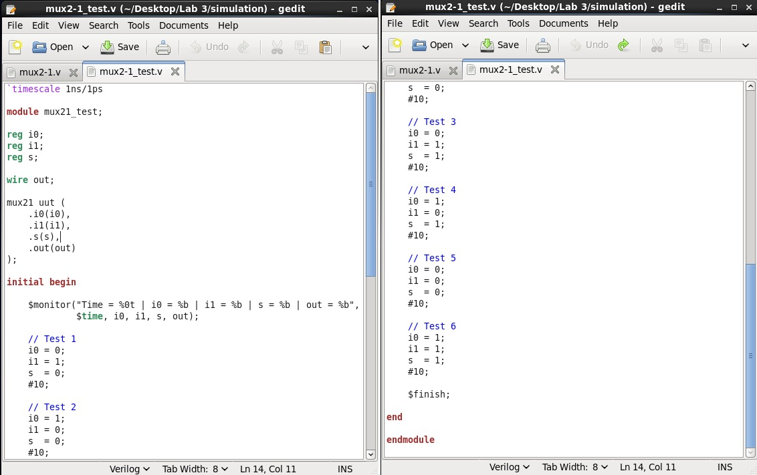
Figure-1.2. Verilog test bench source code (mux21_test.v), instantiating mux21 as uut and applying six 10 ns-wide stimulus vectors (Test 1 to Test 6) to i0, i1 and s while monitoring the output out.
The design and test bench files were compiled with ncvlog and elaborated with ncelab from within NCLaunch; both worklib entries (mux21 and mux21_test) and the resulting Snapshots entry (worklib.mux21_test:module) appear in the NCLaunch window with no errors reported in the Command Entry Window, confirming successful compilation and elaboration, as shown in Figure-1.3.
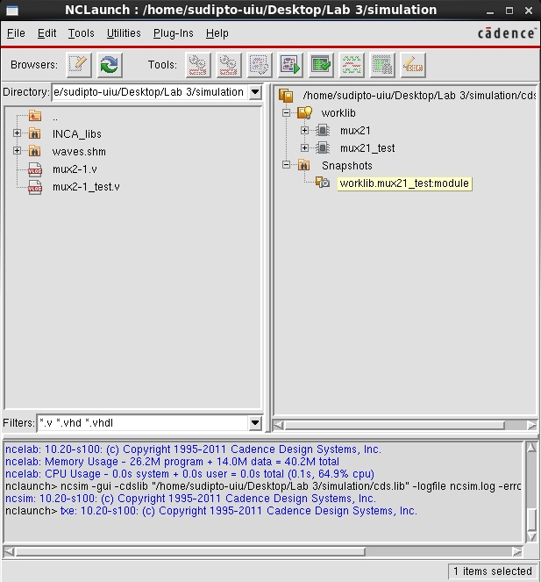
Figure-1.3. NCLaunch window for the 2-to-1 multiplexer, showing the worklib with the compiled mux21 and mux21_test modules, the elaborated Snapshots entry, and the Command Entry Window confirming compilation and elaboration completed without errors.
The elaborated snapshot was then simulated; the SimVision Design Browser lists the i0, i1, out and s signals of mux21_test with their final recorded values, and the Console window’s $monitor output confirms that, for example, out correctly follows i1 when s = 1 and i0 when s = 0, with the simulation completing via $finish at 80 ns, as shown in Figure-1.4. The corresponding SimVision waveform, plotting i0, i1, out and s over the full 80 ns of simulated time, is shown in Figure-1.5.
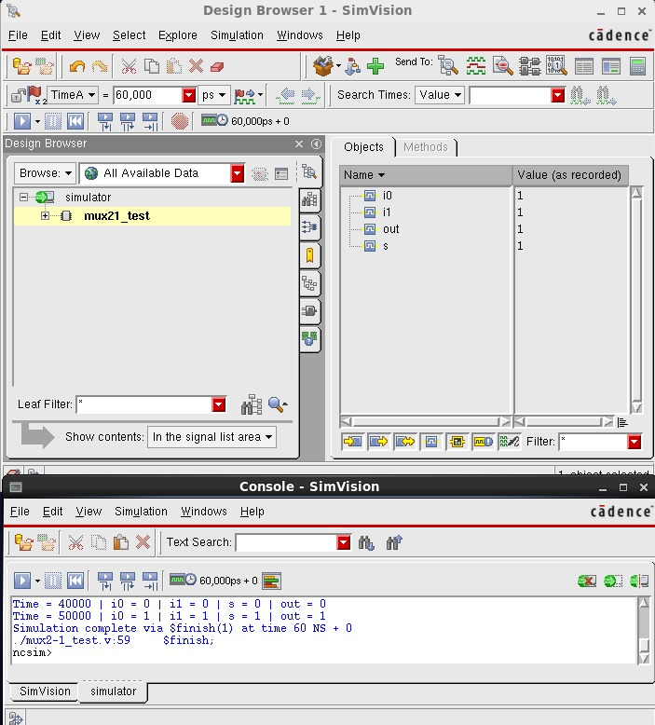
Figure-1.4. SimVision Design Browser and Console windows for mux21_test, showing the recorded signal values and the $monitor output confirming correct 2-to-1 MUX behaviour, with the simulation completing via $finish at 80 ns.
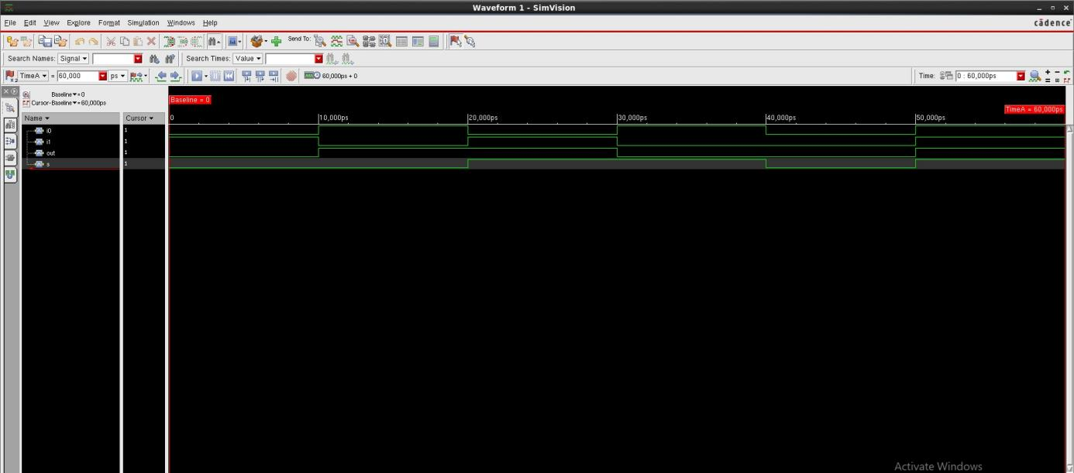
Figure-1.5. SimVision waveform for mux21_test, showing the i0, i1, out and s signals over the full 80 ns simulation; out is seen to track i0 while s = 0 and i1 while s = 1, matching the 2-to-1 MUX truth table.
1.4.2 4-to-1 Multiplexer (mux41)
The 4-to-1 multiplexer was described using vector notation, with a 4-bit input vector i[3:0] and a 2-bit select vector s[1:0], and a single dataflow statement built from a nested conditional expression, out = s[1] ? (s[0] ? i[3] : i[2]) : (s[0] ? i[1] : i[0]), which selects the addressed bit of i directly according to the two select bits rather than instantiating separate 2-to-1 MUX modules. The Verilog source code is shown in Figure-1.6.
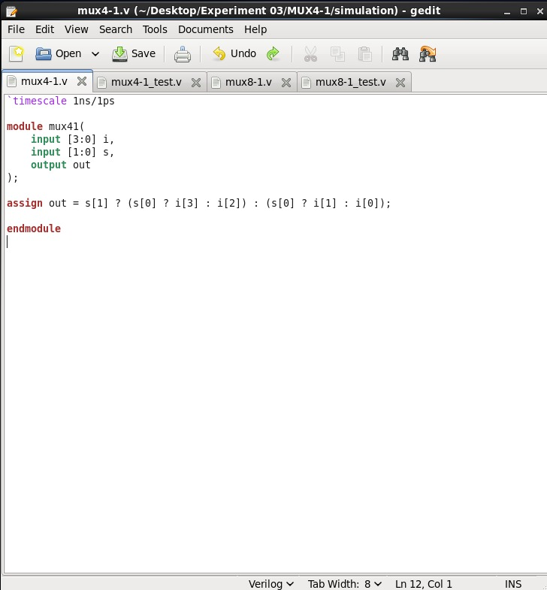
Figure-1.6. Verilog source code (mux4-1.v) for the 4-to-1 multiplexer: a vector-based dataflow description with a 4-bit input i[3:0] and a 2-bit select s[1:0], using a nested conditional expression to select the addressed input bit.
The test bench (mux4-1_test.v) declared four scalar data registers i0-i3 and a 2-bit select register s, connected the four scalars to the vector input port of the design under test using a concatenation, .i({i3, i2, i1, i0}), and applied eight stimulus vectors (10 ns each) covering all four values of the select line, with two different input patterns exercised at each select value, while a $monitor statement printed every signal on each change. The test bench source code is shown in Figure-1.7.
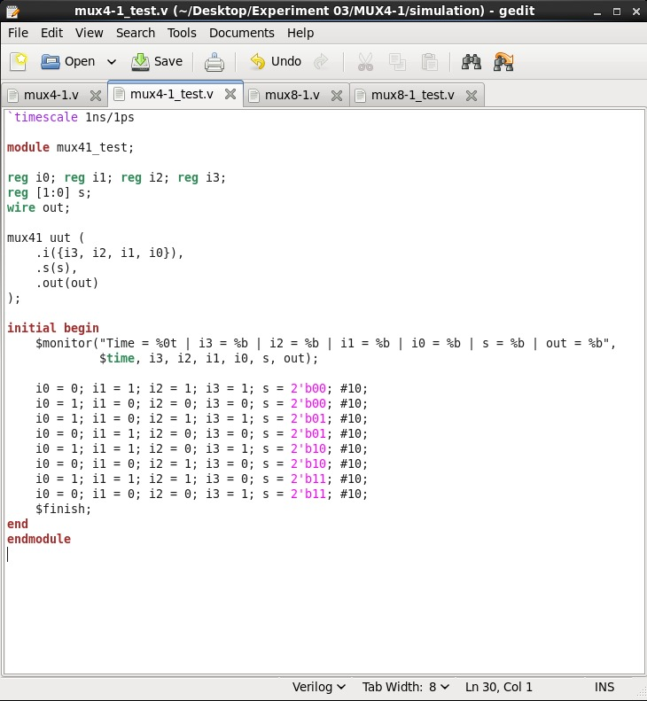
Figure-1.7. Verilog test bench source code (mux4-1_test.v), connecting scalar registers i0-i3 to the vector input of mux41 via concatenation, .i({i3, i2, i1, i0}), and applying eight 10 ns-wide stimulus vectors over the four select values.
The design compiled and elaborated without errors, with the worklib populated with the mux41 and mux41_test modules and a Snapshots entry for worklib.mux41_test:module, as shown in Figure-1.8.
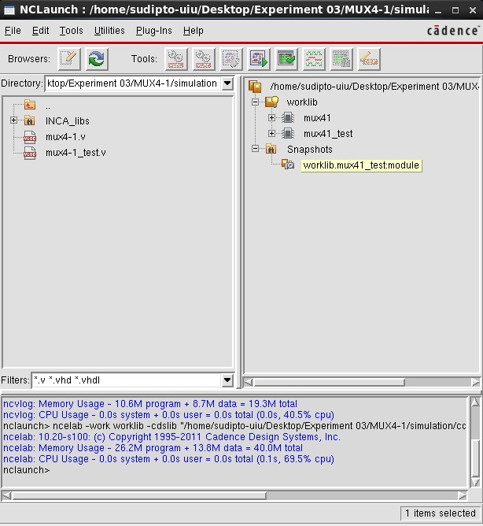
Figure-1.8. NCLaunch window for the 4-to-1 multiplexer, showing the worklib with the compiled mux41 and mux41_test modules and the elaborated Snapshots entry, confirming successful compilation and elaboration.
The SimVision Console output confirms correct operation across the applied select values for example, at select value s = 2’b10 the output correctly follows i2, and at s = 2’b11 the output correctly follows i3 as shown in Figure-1.9, and the corresponding waveform, plotting i0-i3, out and the select vector s[1:0] over the full 80 ns of simulated time, is shown in Figure-1.10.
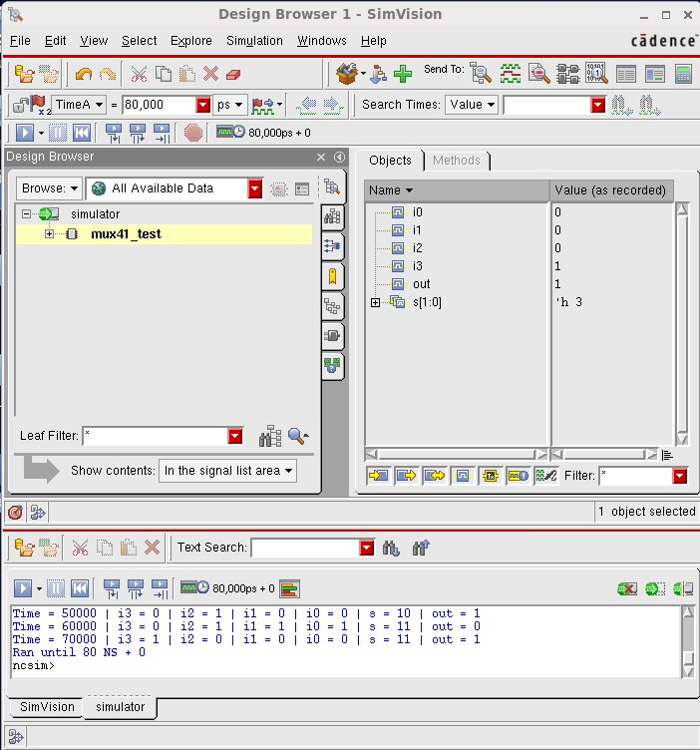
Figure-1.9. SimVision Design Browser and Console windows for mux41_test, showing the recorded signal values and $monitor output confirming that out correctly tracks the input addressed by the select vector s[1:0].
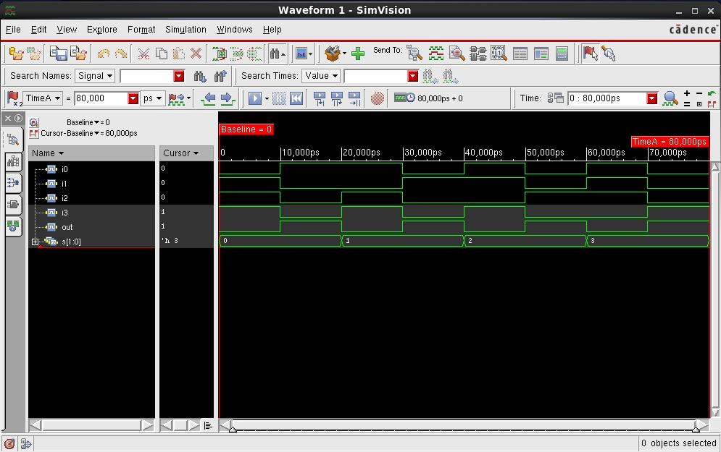
Figure-1.10. SimVision waveform for mux41_test, showing i0-i3, out and the select vector s[1:0] over the full 80 ns simulation, confirming correct 4-to-1 MUX behaviour for all four select values.
1.4.3 8-to-1 Multiplexer (mux81)
The 8-to-1 multiplexer was described in the same vector-based dataflow style as the 4-to-1 design, but extended to an 8-bit input vector i[7:0] and a 3-bit select vector s[2:0], using a three-level nested conditional expression to select the addressed input bit for all eight possible select values. The Verilog source code is shown in Figure-1.11.
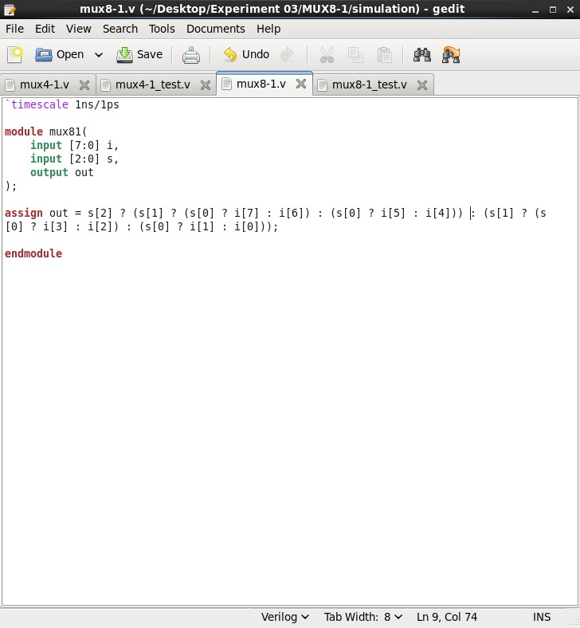
Figure-1.11. Verilog source code (mux8-1.v) for the 8-to-1 multiplexer: a vector-based dataflow description with an 8-bit input i[7:0] and a 3-bit select s[2:0], using a three-level nested conditional expression to select the addressed input bit.
The test bench (mux8-1_test.v) declared eight scalar data registers i0-i7 and a 3-bit select register s, connected the eight scalars to the vector input port via concatenation, .i({i7, i6, i5, i4, i3, i2, i1, i0}), and applied sixteen stimulus vectors (10 ns each, 160 ns total) covering all eight select values, with two different input patterns exercised at each select value, while a $monitor statement printed all eight input bits, the select value, and the output on every change. The test bench source code is shown in Figure-1.12.
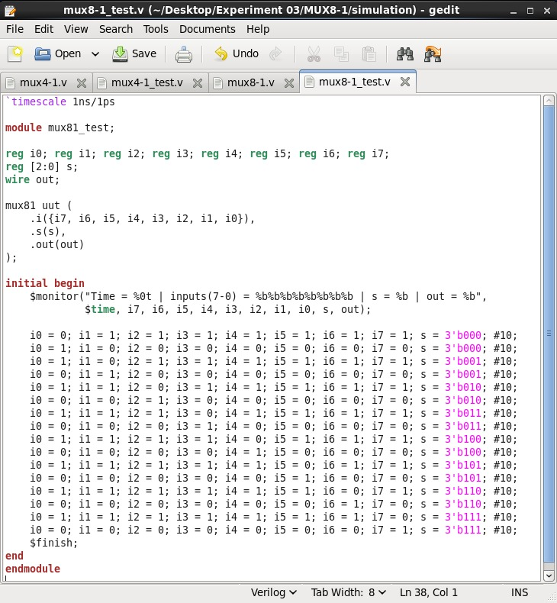
Figure-1.12. Verilog test bench source code (mux8-1_test.v), connecting scalar registers i0-i7 to the vector input of mux81 via concatenation and applying sixteen 10 ns-wide stimulus vectors covering all eight select values.
The design compiled and elaborated without errors, with the worklib populated with the mux81 and mux81_test modules and a Snapshots entry for worklib.mux81_test:module, as shown in Figure-1.13.
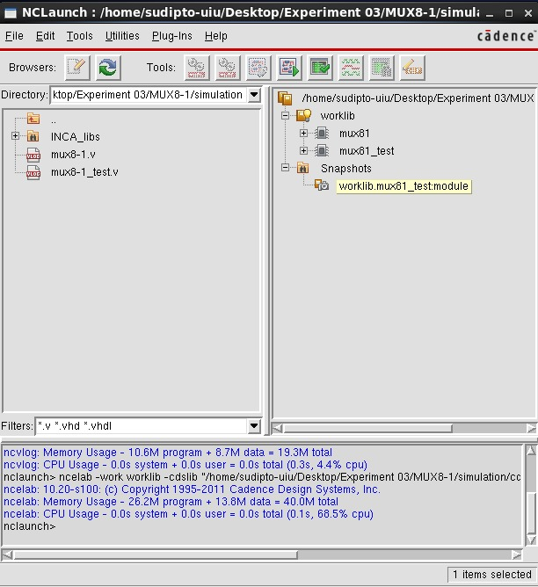
Figure-1.13. NCLaunch window for the 8-to-1 multiplexer, showing the worklib with the compiled mux81 and mux81_test modules and the elaborated Snapshots entry, confirming successful compilation and elaboration.
The SimVision Console output for the recorded portion of the run confirms correct operation for example, at select value s = 3’b010 the output correctly follows i4, and at s = 3’b011 the output correctly follows i3 as shown in Figure-1.14. The corresponding waveform, shown in Figure-1.15, plots i0-i7, out and the select vector s[2:0] over the first 80 ns of simulated time (select values 3’b000 through 3’b011); the remaining select values (3’b100 through 3’b111), simulated over the second half of the 160 ns run, followed the same pattern of the output correctly tracking the addressed input bit, consistent with the $monitor output recorded in the Console.
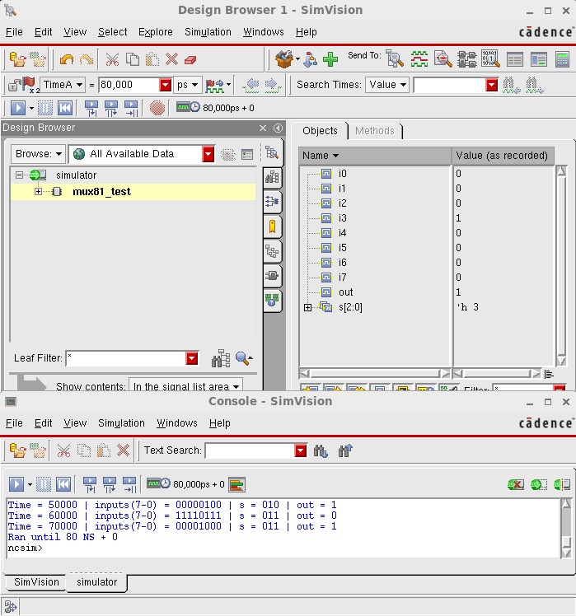
Figure-1.14. SimVision Design Browser and Console windows for mux81_test, showing the recorded signal values and $monitor output confirming that out correctly tracks the input bit addressed by the select vector s[2:0].
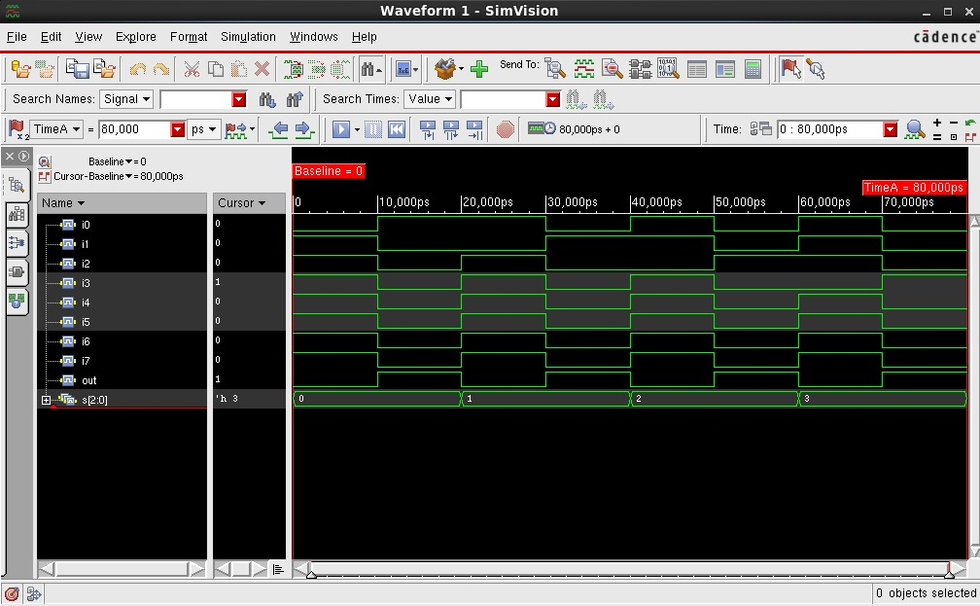
Figure-1.15. SimVision waveform for mux81_test, showing i0-i7, out and the select vector s[2:0] over the first 80 ns of simulation (select values 3’b000-3’b011), confirming correct 8-to-1 MUX behaviour across the recorded select values.
1.5 Discussion
The 2-to-1 multiplexer was written as a structural/dataflow description operating on scalar inputs: a single continuous-assignment statement, out = s ? i1 : i0, directly mirrors the two-input truth table with one conditional operator. The 4-to-1 and 8-to-1 multiplexers were instead written as vector-based dataflow descriptions, in which the data inputs and select lines were declared as multi-bit vectors and a nested conditional expression selected the addressed bit according to every select bit at once; rather than being built structurally from instances of the 2-to-1 MUX, the 4-to-1 design used its own nested s[1]/s[0] conditional over a 4-bit input vector, and the 8-to-1 design extended the same pattern one level deeper using s[2]/s[1]/s[0] over an 8-bit input vector. This vector-based style scales far more compactly than chaining multiple 2-to-1 MUX instances together the 8-to-1 MUX needed only one nested expression rather than seven 2-to-1 MUX instances arranged in a tree while each level of nesting still corresponds conceptually to one stage of 2-to-1 selection, so the 4-to-1 design can be read as two levels of 2-to-1 selection and the 8-to-1 design as three.
1.6 Conclusion
In this experiment, three multiplexers of increasing size a 2-to-1, a 4-to-1, and an 8-to-1 MUX were successfully described in Verilog HDL and verified using the Cadence Incisive Enterprise Simulator (IES) through the NCLaunch design flow. The 2-to-1 MUX was implemented as a scalar dataflow description, while the 4-to-1 and 8-to-1 MUXes were implemented as vector-based dataflow descriptions using nested conditional expressions over multi-bit input and select vectors. Each design was compiled with ncvlog, elaborated with ncelab, and simulated, and the resulting SimVision waveforms and $monitor console output confirmed correct multiplexer behaviour for the applied test vectors in every case. This experiment provided practical, hands-on experience with dataflow Verilog modeling at increasing levels of scale, and with the Cadence IES/NCLaunch compile-elaborate-simulate flow, which forms the basis for verifying larger digital designs in subsequent experiments.

